cONGO RIVER

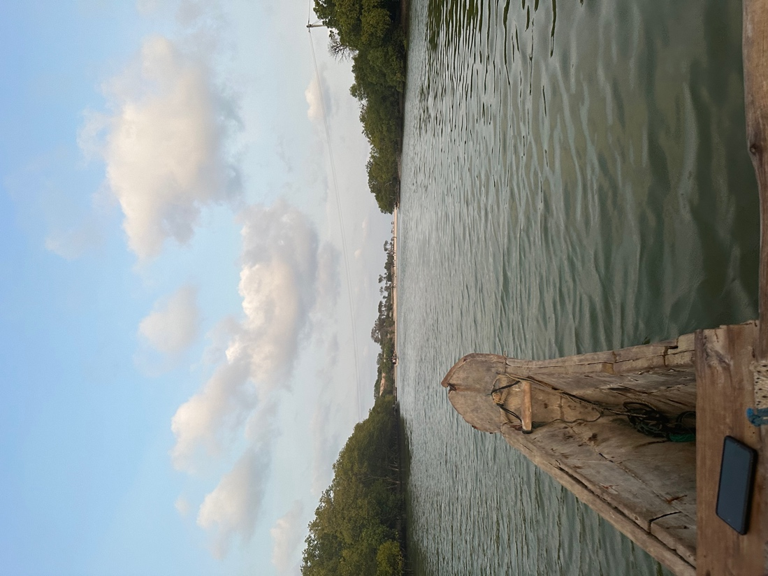

## fROM dIANI AND AROUND

Enjoy a romantic canoe ride along the Kongo River between Tiwi and Diani beaches. This walk will be at sunset.

The many birds and mangroves will welcome you.

The departure is near the oldest mosque on the coast, surrounded by many baobabs. Departure 5pm from Diani beach, return around 7pm

**PER PERSON : 15 € (transport included)**