SHIMBA HILLS – SHELDRICK FALLS

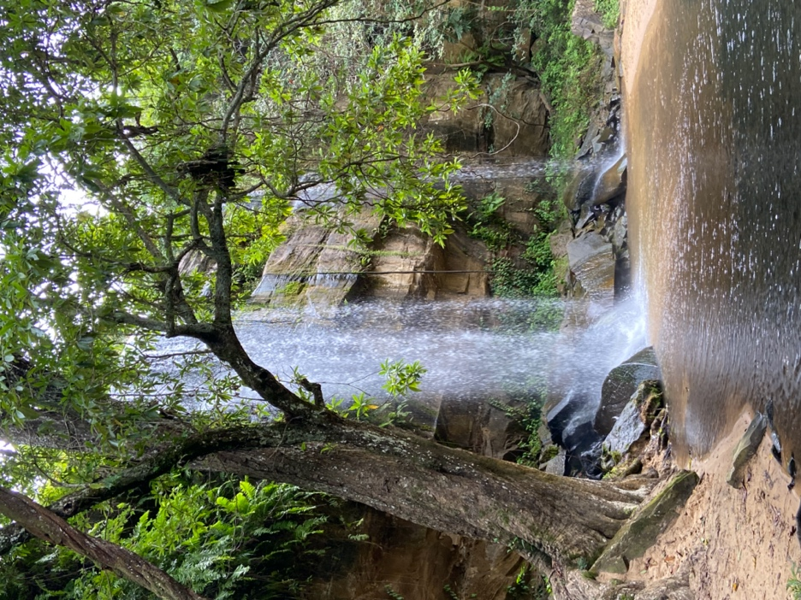

## DEPARTURE FROM DIANI AND AROUND

## Shimba Hills

Shimba Hills is located in the Kwale district on the southern coast of Kenya. This area, made up of tropical forests, woods and grasslands, is home to the highest density of African elephants (around 700). Several breathtaking viewpoints will offer you splendid panoramas of the surrounding rolling hills and forests. To the east, you can see the Indian Ocean with Chale Island while to the west extends from the Tsavo plains to the the Taita hills.

Being one of the largest coastal forests in East Africa, this reserve is rich in flora and fauna with great biodiversity.

You will be able to meet animals such as herds of elephants, giraffes, hyenas, warthogs, buffaloes, monkeys. Shimba Hills is also home to the last breeding herd of Kenya's native sable antelopes. In addition, 111 species of birds have been recorded in this area.

Sheldrick falls

The famous Sheldrick Waterfalls are a highlight of the area that you will visit during this outing. From the viewing platform, you will descend a number of stairs. You will walk for about 30 minutes through the forest to reach the waterfall and the refreshing water pool at the foot of the falls. A ranger will accompany you on this route.

After the trip, you will head to the Shimba Green Lodge to relax in the swimming pool facing a huge view of the park. You can also enjoy delicious local and international food. Depending on the time, you can admire a splendid sunset over the savannah.

**PRICE PER PERSON : 60 € (the meal and the drinks at the restaurant are not included)**