taita hills

Safari 2days/1 night all inclusive (excepted drinks)

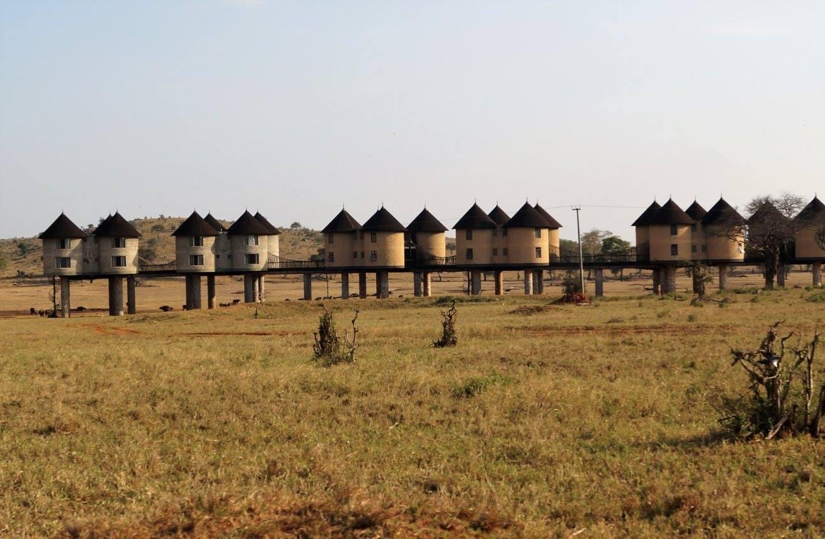

**AMOUNT PER PERSON : 450 $ (MINIMUM 2 PERSONs)**

Kids under 10 years old – 50% on the total amount per person for a child sharing a room with 2 adults/ children below age of 5 years old are not allowed due to safety and noise reasons.

**Your schedule for your safari**

* 6 am departing from the villa
* Break around 10am (breakfast)
* 1pm arrival at **Taita Hills Safari Resort and Spa for the** lunch (drink not included), possibility to relaxing at the swimming pool
* 3pm departure for your room at **Sarova Saltlick**
* 4pm safari game until the sunset
* Buffet dinner (drink not included)
* Possibility to go for a safari game night
* Night at Sarova Saltlick
* **It’s possible to observe wild animals drinking on the front of you or to go through a tunnel to see them vey near**

**2nd day**

* 6am Buffet Breakfast
* 7am Safari game
* Around 10 am departure for Diani
* Lunch around 1pm in a souvenir shop
* Arrival around 5pm at the villa

If you want, we can book a visit of a Masai Village on our way back. Just ask for it in the same time you book your safari.

20 $ person

